Cookie Mining
Names:
Cookie mining: The purpose of this lesson is to understand the full cycle of mining minerals. We will glance at the economics of mining and its effect on the environment. You will be purchasing “land” (cookie) and “mining equipment” (flat toothpick, round toothpick, paper clip). You will mine the cookie (land) for minerals (chocolate chips) and then restore the land (reclaim the land through the process of reclamation) once you have finished mining. You will need to mine the minerals, quantify your minerals, reclaim the land, and complete the profit/loss worksheet. Manage your time wisely. Time is money in the mining industry!

Objective:
- You will “mine” for ore (chocolate chips) with a goal of making as much money as possible while preserving the environment.
- Your land permit allows for 10 minutes worth of mining and 2 minute of reclamation. You must abide by the following mining regulations:
  - You will start with $180 million,
  - You can only purchase one piece of land.
  - Hands may NOT be used at any point during mining (not even to hold the cookie). You may only use the mining tools to mine your land so purchase equipment wisely!
  - Mining Equipment CANNOT be shared nor can it be purchased once mining has begun
  - If a piece of equipment breaks you may fix it with one piece of tape (located at the front of the room) for the cost of $10 million but whatever time lost to repairs cannot be made up.
  - You will have 2 minutes to reclaim your land—this includes putting the cookie and subsequent crumbs back within the original scope of the mining operation. Additional time spent reclaiming will cost additional money ($10 million per minute), but cookie pieces/crumbs that aren’t reclaimed will be subject to steep environmental fines ($5- $20 million)
  - All mined ore (chocolate chips) must be cleaned and transported to the processing plant on your paper.
  - Ore that moves outside of the Mining Area Grid (the desk, the floor, etc) cannot be retrieved.
  - AT NO POINT should you brush away, blow or remove crumbs- this will result in environmental fines.
Procedure:
- Obtain your land and record the price of land under Part A. Land Acquisition. The land price is as follows:
  - Low mineral cookie, hard land: $20 million
  - Medium mineral cookie, soft land: $40 million
  - High mineral cookie, dry land: $60 million
- Place your cookie on the provided Mining Area Grid and trace. Looking from the side, sketch the topography (the natural, physical features of the land) on the “Pre-mining Topography” graph on Part B. Topography Study.
- Near your cookie, trace a 2x2 box that will serve as a processing plant for your ore.
- Record the types of natural attributes impacted by your mining operation including the cookie placement as well as the processing plant. Record the number of squares/attributes directly impacted by your mining/processing placement and record in column two of Part C. Environmental Impact.
- Obtain your mining equipment. You may purchase up to THREE pieces of equipment (you can mix and match). Record your equipment choices under Part D. Equipment Costs.
  - Flat toothpick: $50 million
  - Round toothpick: $70 million
  - Paperclip: $90 million
- Once all data is recorded, wait for teacher to officially commence your mining operation.
- Once mining has been completed, your teacher will officially start the time for reclamation—you have 2 minutes to move all crumbs/cookie BACK into the circle you traced. Any grid with a crumb will face an environmental fine of $5 million per grid and/or $20 million per smudge. You may use additional time to reclaim at the cost of $10 per minute. Record this, if applicable, in Part E. Reclamation.
- Once mining has stopped your tablemates will collectively serve as EPA Agents Assessors as well as determine the amount of successful ore retrieved.
EPA Agent Duties:
- Determine, collectively, how many grids contain cookie/crumbs the mining operation left behind-- the tiniest speck counts! Even if it’s as big as this period . it counts!
- Mark the grids that have crumbs/unreclaimed cookie- later shade each impacted grid
- record this number in Part E. Reclamation
- If any crumb/smudge is left unreclaimed on a natural attribute, record this in column 2 of Part C. Environmental Impact
- Determine how many smudges (acid mine drainage) were left over after reclamation and record in Part E. Reclamation
- Determine how many pieces of ore were successfully transported to the processing facility. Determine which ore is whole and clean, partial and clean, whole and dirty, as well as partial and dirty. Record this number under Part F. Mining Evaluation.
- Draw the post-mining topography of your land in Part B. Topography Study
- Once your land and ore have been assessed by the EPA agent you may chow down on any left over cookies.
Post Mining Assessment:
The Mineral Area Grid contains:

- 41 Water squares
- 33 Trees
- 12 Areas rich in topsoil
- 10 Deer
- 9 Beautiful Vistas

- Because the water flows from north to south, water that is compromised upstream can have an effect on water quality downstream. For any water square compromised (having a crumb/smudge), all connecting water downstream (below) is also impacted. Record how much water is affected in the third column in Part C. Environmental Impact. Put Xs through all polluted water icons on the mining area grid.
- Topsoil requires 3 clean water squares to maintain moisture (it cannot share these squares with other patches of topsoil). Any top soil that loses moisture by not having enough water will be prone to erosion, Record how much top soil is effected in the third column in Part C. Environmental Impact. Put X’s through all dried up top soil icons on the mining area grid.
- A maximum of 3 trees need 1 square of rich topsoil to survive (they cannot share these squares with other clusters of trees). Record how many trees remain after your mining operation and record in the third column of Part C. Environmental Impact. Put Xs on all tree icons that die because of insufficient nutrients.
- Each deer requires 3 tree squares and 3 water squares to survive (they cannot share these squares with other deer). Record how many deer are impacted by polluted water and a decrease in foliage in the third column of Part C. Environmental Impact. Put Xs on all deer that can no longer survive in the environment.
- Vistas are aesthetically pleasing areas where people can enjoy the scenic view. In order for vistas to maintain their integrity, they cannot have a decrease in biodiversity or water pollution nearby. ANY box touching the vista (this includes the top and bottom corners) that has an X is tarnishing the aesthetic beauty of the vista, making it no longer appealing. Record how many vistas are altered in the third column of Part C. Environmental Impact and put Xs over them.
- Staple your Mining Area Grid to the back of your lab.
___________________________Mining Assessment
(Name your Mining Company)
A. Land Acquisition Costs
Name of land: ________________________________________________ Total Land Cost: _____________

B. Topography Study
C. Environmental Impact
Natural Attribute | Quantity Directly Impacted by Placement | Quantity  Directly Impacted by Mining | Quantity Indirectly Impacted by Mining Operation | Remaining Healthy Natural Attributes
Tree
Deer habitat
Rich Topsoil
Water
Beautiful Vista

Equipment Type | Quantity | Price | Total Costs
Flat Toothpick |  | 50 mil
Round Toothpick |  | 70 mil
Paperclip |  | 90 mil
Repairs |  | 10 mill

Total Equipment Costs
D. Equipment Costs

E. Reclamation Cost
Reclamation | Quantity | Cost | Total
Additional time |  | $10 million
Unreclaimed Grids |  | $5 million
Smudges |  | $20 million
Operations |  | $20 Million | $20 Million
Total

F. Mining Evaluation
Type of Ore | Quantity | Tons per chip | Price | Totals
Whole, clean |  | 4 million | $15/Ton
Partial, clean |  | 2 million | $13/Ton
Whole, dirty |  | 4 million | $10/Ton
Partial, dirty |  | 2 million | $5/Ton
 |  |  | Total:
Corporate Tax rate is 10% |  |  | Taxes to be paid:

G. Profit/Loss Statement
Add up the following mining related costs to determine the amount of start up money needed/used:
 | Losses
Total Land Costs
Total Equipment Cost
Reclamation Costs
Facility Costs (office buildings, roads, utilities) | 50 million
Operating Costs (fuel, salaries, maintenance repairs) | 100 million
Environmental Costs (permitting, pre-mine studies including a $50 million bond) | 80 million
Total

Determine if you have made a profit or if you will have to file for Chapter 11 bankruptcy.

Subtract total costs (losses) from start up cost of $180 + income (profit): ___________________
If the answer is positive you made a profit!
If the answer is negative you suffered a loss!

Final Disclosure Statement:
___________________________________________________ reports a net ___________________
Company’s Name (profit/loss)

Of $______________________________ for quarter 1, _____________.
(amount calculated above) (year)
________________________________________
(signed)
Chief Financial Officer
 | Profit
Money earned from retrieved ore
Salvage credits (selling equipment, office furniture, computers, etc) | 30 million
Total
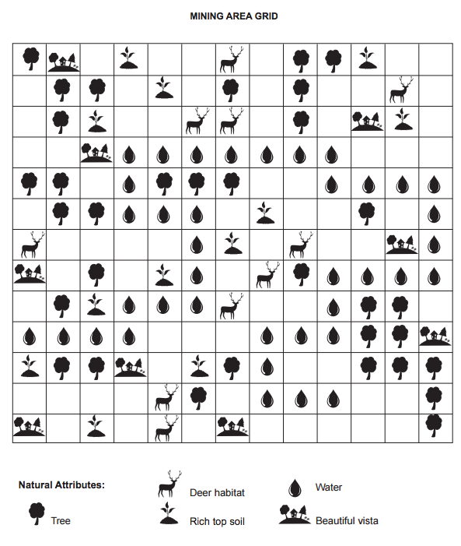
Conclusion Questions—answer the following in complete sentences:
- We studied several types of mining techniques, which one would be most effective in mining your cookie?

- Explain how the minerals were distributed throughout the cookie mines. Was this simulation, in regards to minerals, true to real life? Why or why not?

- What did the mined cookie, before reclamation, represent? Use specific vocabulary term.

- Did you leave any chips behind in your cookie? Why or why not?

- Were you able restore the mined cookie to exactly its original size and topography? Why or why not?

- Why do you think a “smudged” was analogous to acid mine drainage in this simulation?

- Is the additional expense of mine reclamation necessary? Why or why not?

- Describe the ecological impacts your mine had on the local environment?

- How did the “Environmental Regulations” hurt your profit? Which regulation hurt your profits the most?

- List 5 objects you use every day that contain some type of mineral, what is the object and what mineral does it use (include the mineral. i.e. Pencil – Graphite)

