- Sub-marine canyon (A)

- Continental Rise (K)

- Continental shelf (F)

- Continental Slope (B)

- Seamounts (C)

- Goyots (G) | A flat-topped underwater mountain. Used to be at surface.
- Atolls (E) | A ring-shaped coral reef
- Mid-ocean ridge (D)

- Rift Valley (J) | Deep Faulted valley found along divergent plates.
- Abyssal plain (I)

- Deep-sea trench | Deepest part of the ocean floors where plates are subducted
- Shoreline (Beach) (L) | Where the Ocean meets the land
- SONAR (pg 398)

- Divergent Boundary (p262)
- Convergence Boundary (p262)
- Subduction (p256)

- Sea-floor speeding
- Transform Fault (263)

- Convection currents (p269)
- Island Arc System | Volcanic Islands formed because of subduction of tow ocean plates. Ex. Japan & Philippines
- Turbidity Currents (A &B)
Ocean Floor Features Vocabulary Name: Date:
Letters in Parentheses are to be labeled on Diagram
Ocean Floor Features Vocab
The Ocean Floor: Revealing Plate Tectonics Name: _________________________________
Ocean Floor (New Discoveries): Thanks to SONAR (Sound Navigation and Ranging) the sea floor was mapped revealing numerous features.
Identify the ocean floor features labeled A-M on the diagram below. Use Vocabulary sheet letters to help.
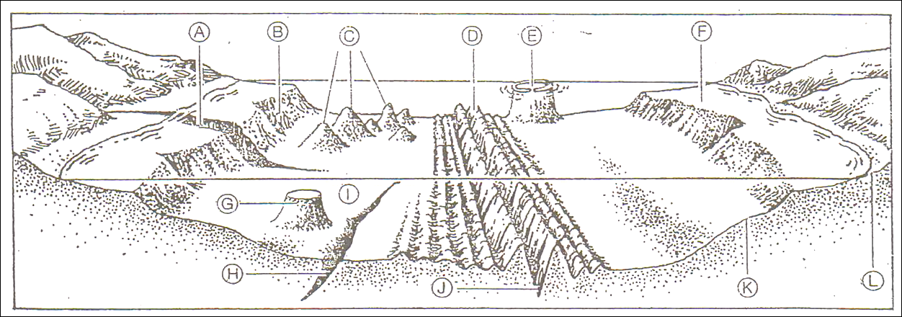

A/ ____________________________________________________________________________________
B/ ____________________________________________________________________________________
C/ ____________________________________________________________________________________
D/ ___________________________________________________________________________________
E/ ___________________________________________________________________________________
F/ ___________________________________________________________________________________
G/ ___________________________________________________________________________________
H/ ___________________________________________________________________________________
I/ ___________________________________________________________________________________
J/ ___________________________________________________________________________________
K/ ___________________________________________________________________________________
L/ ___________________________________________________________________________________
