Endangered Species Mini Project (45pts)zoology
Name:
==========================================
Powerpoint/prezi option:
- The slide show should, at the minimum, follow the following format
_{Slide 1}  Title: name of species  (common name and Scientific name)  Your name  _{Picture} | _{Slide 2}  Slide Title  - Is the species endangered threatened, or vulnerable? What does that mean?  - Why is the species endangered?  Picture | _{Slide 2}  Slide Title  - Physical Description of your species.  - Unique facts about your species  - taxonomy: what kingdom, phylum, class, order, family, genus, and species group does it belong to.  Picture
Slide 4  Slide Title  - Describes your species habitat  Picture | Slide 5  Slide Title  Ecology Slide:  - Describe how your species fits in the food web.  - What would happen to your species environment if it were to go extinct.  - What impacts on Humans would there be if your species went extinct  Picture | Slide 6  Slide Title  - What is being done or what can be done to save your species from extinction  Picture

Website Option (preferred, just email me the link)
Use www.weebly.com to create a website.
You will have to create an account.
The website should include all the same information as described in the PowerPoint
Rubric:
 | 0-1pt | 2pt | 3pts | 4pts | 5pt
Slide 1 | Off topic  Doesn’t address questions | Zero to 50% of the questions and topics are missing and or incorrect | Missing 1-4 questions/topics  Some content is accurate some is incorrect. | Every questions and topic is addressed  Content is accurate | Every question and topic is answered.  Goes beyond what is asked  Content is accurate
Slide 2 | Off topic  Doesn’t address questions | Zero to 50% of the questions and topics are missing and or incorrect | Missing 1-4 questions/topics  Some content is accurate some is incorrect. | Every questions and topic are addressed  Content is accurate | Every question and topic are answered.  Goes beyond what is asked  Content is accurate
Slide 3 | Off topic  Doesn’t address questions | Zero to 50% of the questions and topics are missing and or incorrect | Missing 1-4 questions/topics  Some content is accurate some is incorrect. | Every questions and topic are addressed  Content is accurate | Every question and topic are answered.  Goes beyond what is asked  Content is accurate
Slide 4 | Off topic  Doesn’t address questions | Zero to 50% of the questions and topics are missing and or incorrect | Missing 1-4 questions/topics  Some content is accurate some is incorrect. | Every questions and topic are addressed  Content is accurate | Every question and topic are answered.  Goes beyond what is asked  Content is accurate
Slide 5 | Off topic  Doesn’t address questions | Zero to 50% of the questions and topics are missing and or incorrect | Missing 1-4 questions/topics  Some content is accurate some is incorrect. | Every questions and topic are addressed  Content is accurate | Every question and topic are answered.  Goes beyond what is asked  Content is accurate
Slide 6 | Off topic  Doesn’t address questions | Zero to 50% of the questions and topics are missing and or incorrect | Missing 1-4 questions/topics  Some content is accurate some is incorrect. | Every questions and topic are addressed  Content is accurate | Every question and topic are answered.  Goes beyond what is asked  Content is accurate
On time | late | --- | --- | --- | On time
Written in own words | Copy and pasted | --- | --- | --- | Written in own words
Pictures | 0-1 pictures | 2 pictures | 3 Pictures | 4 Pictures | 5 pictures
Due Date: October 16th
Calendar and Timelines

Monday | Tuesday | Wednesday | Thursday | Friday
8  No school | 9  Library  - Pick an endangered species  - Start researching topic questions | 10  Library  - Research Topic Question | 11  Library  - Finish Research  - Start Powerpoint, prezi, or weebly | 12  Library  - Work on Powerpoint, Prezi, or weebly
15  Library  - Finish project | 16  Project Due  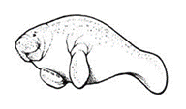 | 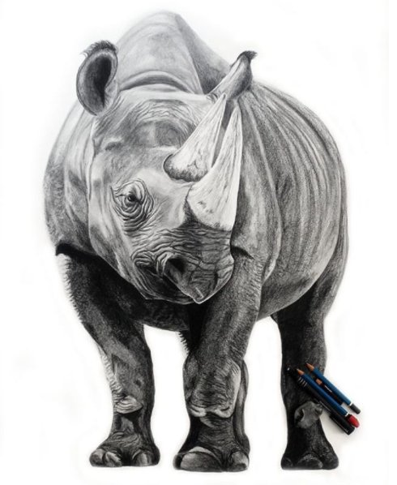 | 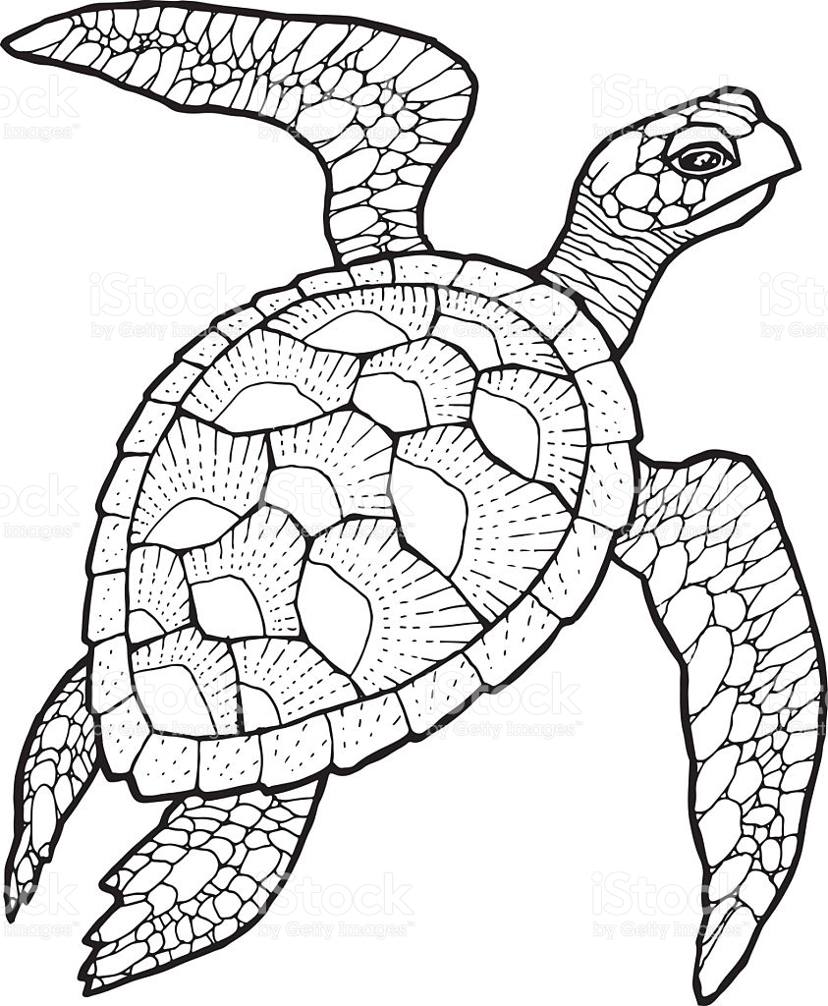

Topic Question Notes:
Slide 1
Common Name of species: ______________________________________________

Scientific Name of Species: ______________________________________________
Slide 2
- Is the species endangered threatened, or vulnerable? What does that mean?

- Why is the species endangered (hunting, habitat lost, climate change, invasive species etc)? Explain

Slide 3
- Physical Description of your species. (Size, color, carnivore, omnivore, mammal, bird, what does it eat?)

- Unique facts about your species. Fun or interesting things about you species.

- taxonomy: what kingdom, phylum, class, order, family, genus, and species group does it belong to.

Slide 4
- Describes your species habitat (where does it live, what biome(Jungle, mountain, tundra, ocean, desert, underground, etc) (trees, what kind of plants, rain, dry, wetland (swamp) etc)

Slide 5
- Describe how your species fits in the food web.

- What would happen to your species environment if it were to go extinct.

- What impacts on Humans would there be if your species went extinct

Slide 6
- What is being done or what can be done to save your species from extinction

