How Can Parents Get Involved in Their Child’s Education?
Your involvement is an integral part of your child’s education! By taking an active role in our school, parents show their children that they are valued and that education is important. Below you will find a variety of ways that you can be involved in the education of your child:

- Read to and with your child daily
- Attend open houses, PTO meetings and parent involvement activities
- Attend parent/teacher conferences
- Join the school PTO and be an actively involved member
- Volunteer in your child’s classroom
- Communicate regularly with your child’s teacher

Title I Parent Brochure
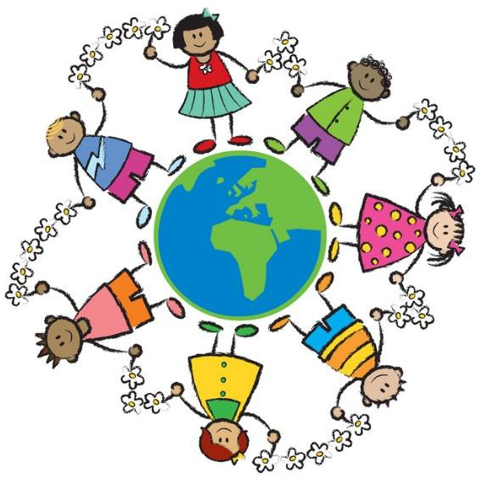

What is Title I?
Title I is one of the nation’s largest federal programs through which school districts receive federal funding to provide supplemental instruction for students based upon academic need. The goal is to increase performance and academic achievement in the areas of language arts and/or mathematics.
Schools are identified as Title 1 based on the economic level of the families who attend.

KH & Title I
- Funding is used to benefit ALL students in
the school.
- KH uses Title 1 funds to purchase
technology, academic resources, host parent meetings and activities, staff salaries, and provide collaborative planning and professional development for teachers.

Purpose of Title I:
- Help every child receive a high quality education
- Build capacity for parent involvement
- Provide professional development for building staff

School Parent Compact
Parents will be asked to review the compact. The compact is an agreement between the parents, student, and school to help ensure each child’s academic success. This acknowledges a shared commitment that all involved are going to work together to improve learning. This compact is required by the Federal Title I guidelines.

