The Form and Structure of Hair (pgs. 110-114)
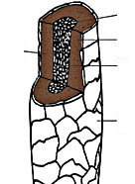
- Another name for the form and structure of something is its ______________.
- In a 24hour period, the average person sheds ____ hairs from the scalp alone.
- Label the parts of the hair shaft pictured here.
- A _________________ is the organ out of which a hair shaft grows.
- Why is analyzing hair useful for drugs and poisons?
- Match the following descriptions of the parts of a hair shaft.
_____ cortex a. spongy interior core of hair that gives it flexibility; appears as a canal in the middle of
the shaft
_____ cuticle b. middle layer of the hair shaft that provides strength; comprises most of the hair mass
_____ medulla c. tough, clear outside covering of the hair shaft
- What is unique about the cuticle of human hair?
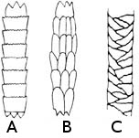
- Identify the origin of the hair shafts pictured here.
_____ Human hair
_____ Mouse
_____ Cat
- Why does human hair have a characteristic odor when it burns?
- The protein of which hair is made is __________________.
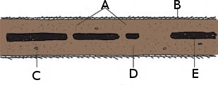
- Label the longitudinal diagram of the hair shaft below.
_____ Cortical fusi
_____ Cortex
_____ Pigment granules
_____ Medulla
_____ Cuticle scales
- Pigment that makes hair black, brown, red or yellow is found in the ___________________.

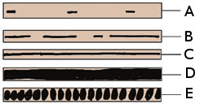
- Distinguish the medulla patterns in the diagram below.
_____ Continuous (human)
_____ Continuous (animal)
_____ Fragmentary
_____ Interrupted
_____ Stacked
- The medulla is normally invisible, except in the hair of which people groups?
- What hair shapes are generally found among these people groups?
African peoples:
Whites, Mexicans, and Middle Eastern peoples:
Asians and Native American peoples:
- Head hair, on average grows ________ cm per month.
- Put the threes stages of growth of hair into chronological order (telogen, catagen, anagen).
- The stage of hair growth that lasts up to five years is the ______________ phase.
- Hairs found on a hair brush are normally from the __________________ phase.
- Match the hair end description with a condition that would explain it.
____ Squared off at the tip A. mature human hair
____ Rounded at the base B. use of harsh chemicals, or overuse of a blow dryer
____ Tapers to a point C. recently cut
____ Frayed or split ends D. uncut for a period of time
- List three reasons how a pencil can be a useful analogy for a hair shaft.
_________________________________________________________________________
_________________________________________________________________________
_________________________________________________________________________
_________________________________________________________________________
_________________________________________________________________________
_________________________________________________________________________
_________________________________________________________________________
_________________________________________________________________________

