14.2 Ocean Floor Features pages 401-405 Name: ____________________________________
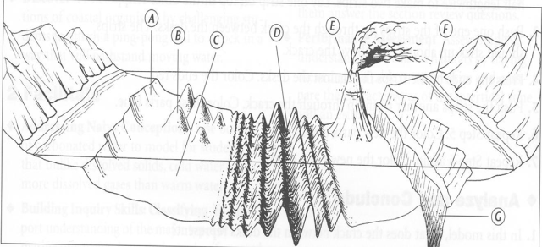
Pearsonsuccessnet.com kar2016 ESS2016
1. What are the three main regions of the ocean floor?

2. What does figure 6 on page 401 show? Study this for a minute.
3. Describe the continental margin in the Atlantic.

4. Describe the continental margin in the Pacific.

5. Why are the continental margins in the Pacific different from those in the Atlantic?

6. What does figure 7 explain? Study this for a minute.
7. How steep is the continental shelf? Why is the continental shelf important to us?

8. What features are cut into the continental slopes? What eroded these features into the slope?

9. What does fig 8 show? Study this for a minute.

10. What are trenches? How are deep ocean trenches formed?

11. What are abyssal plains? How are abyssal plains formed?

12. What is the difference between seamounts and guyots?

13. What is formed at mid-ocean ridges?

14. What happens as super heated waters from hydrothermal vents at the mid-0ocean rift come into contact
with super cold waters of the deep ocean?
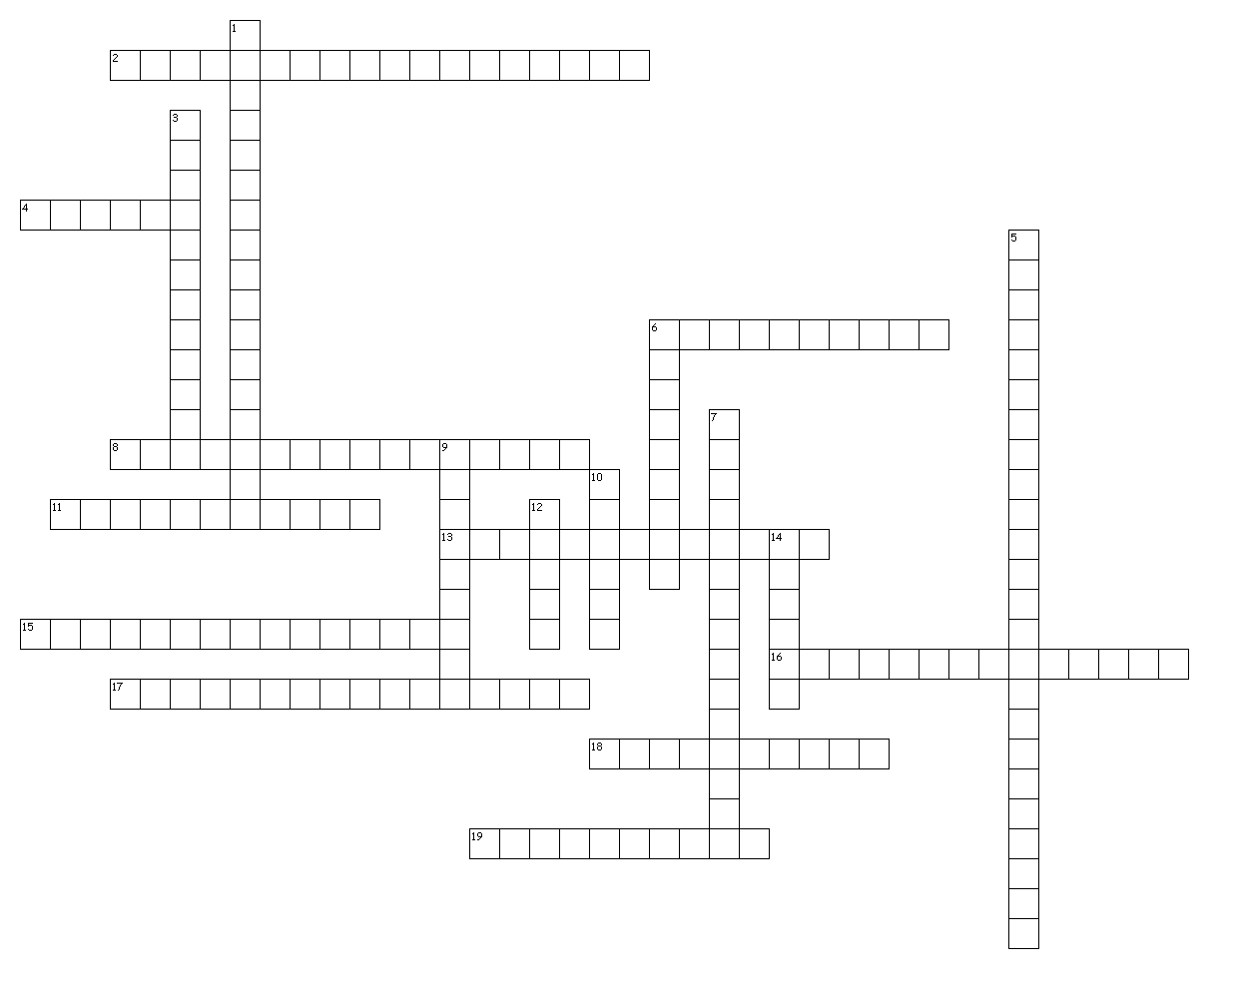
Plate Tectonics
and
Ocean-Floor
Features

Abyssal plain
Atolls
Continental rise
Continental shelf
Continental slope
Convection currents
Convergence
Divergence
guyots
Island Arc System
Mid ocean ridge
Rift valley

Seafloor spreading
Seamounts
Shoreline
SONAR

Subduction
Submarine canyon
Transformfault
Trench

Across
2. …in the upper mantle, drive plate tectonics and sea-floor spreading.
4. Ring-shaped coral reefs. (plural)
6. When an ocean plate goes under another plate and melts.
8. The steep drop to the deep-ocean floor that marks the edge of the continent shelf.
11. When plates collide (come together).
13. A long continuous range of mountains on the sea floor that has a central rift valley. Sea-floor spreading.
15. Underwater canyons that cut across the continental shelf. Contain fast moving mud flows.
16. Sliding plate boundaries. Ex. San Andreas Fault in CA
17. Gently sloping submerged part of the continental margin extending from shoreline to slope.
18. When plates move away from one another (pull apart). Cracking, tearing, rifting.
19. Deep faulted valley found along divergent plates.

Down
1. New crust is formed where the ocean crust splits open and moves apart. This ‘drives’ plate motion.
3. Very level area of the deep-ocean floor…covered by lime (CaCO3) and clay mud.
5. Islands formed as a result of subduction of two ocean plates. Ex….Japan and Philippines.
6. Where the ocean meets the land.
7. Gently sloping surface at the base of the continental slope where sediments pile up.
9. Underwater volcanic mountains. (plural)
10. Deepest part of the ocean floors where plates are subducted.
12. Sound Navigation And Ranging.

