Name:
Vocab: Drugs Part I chapter 7

30
- Use your textbook (p. 169-174) to define the following terms:
DO NOT USE internet sources

Controlled drugs: _______________________________________________________________________.
______________________________________________________________________________________.

Cannabis: _____________________________________________________________________________.
______________________________________________________________________________________.
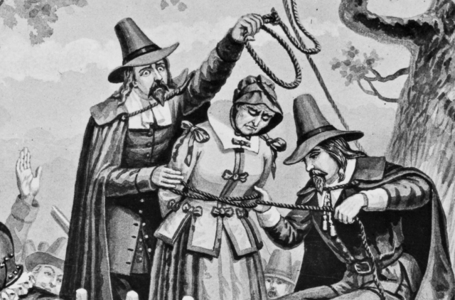
Salem Witch Trials and LSD:
- What is Ergot?

- What did they call it in the middle ages? How many people did it kill?

- What is its connection to the famous Salem Witch Trials of 1692?

Hallucinogens: __________________________________________________________________________.
______________________________________________________________________________________.
Most Common Hallucinogen: ____________________________________________________

Teratogen: _____________________________________________________________________________.
______________________________________________________________________________________.

Stimulants: ______________________________________________________________________________________.
______________________________________________________________________________________.
______________________________________________________________________________________.
Nicknames:

Alkaloid: ______________________________________________________________________________.
______________________________________________________________________________________.
Examples:

Describe Qat:___________________________________________________________________________.
______________________________________________________________________________________.
______________________________________________________________________________________.

Analgesics: ____________________________________________________________________________.
______________________________________________________________________________________.
Nicknames:

Designer Drugs: _________________________________________________________________________.
______________________________________________________________________________________.

Barbiturates (“ “ ): _______________________________________________________.
______________________________________________________________________________________.
______________________________________________________________________________________.

- Fill in the missing blanks
Table 7.1: Some OTC Analgesics and Cold Remedies
Trade Name | Active ingredients
 | Pseudoephedrine hydrochloride,
Advil
Aleve
Anacin
Aspirin
Benadryl
 | Acetaminophen, pseudoephidrine hydrochloride, dextromethorphan hydrobromide, chlorpheniramine maleate
 | Acetaminophen, acetylasalicylic acid, caffeine
Motrin
No-Doz
Sudafed
Tylenol
 | Acetaminophen, diphenhydramine hydrochloride

