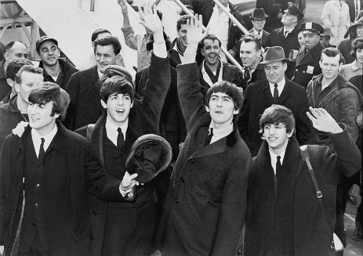
The Beatles
The Beatles were an English rock band that began in Liverpool, England in 1960. They were, and still are, one of the most successful and influential bands in the history of modern music.

The members of the band were John Lennon (rhythm guitar), Paul McCartney (bass guitar), George Harrison (lead guitar) and Ringo Starr (drums). They are sometimes called the “Fab Four”.

They first came to the United States in 1964. They were met at the airport by thousands of screaming American teenagers. The Beatles were so popular that they were attacked by screaming fans everywhere they went around the world. The effect they had on their fans was known as 'Beatlemania'. Their first hit song in the U.S. was “I Want to Hold Your Hand” released in 1964.

The Beatles made their first live American television appearance on The Ed Sullivan Show in February 1964. About 74 million viewers — about half of the American population — watched the group perform on the show. Beatles songs soon filled the top 5 places on the American top 40 chart - a record that has never been matched.

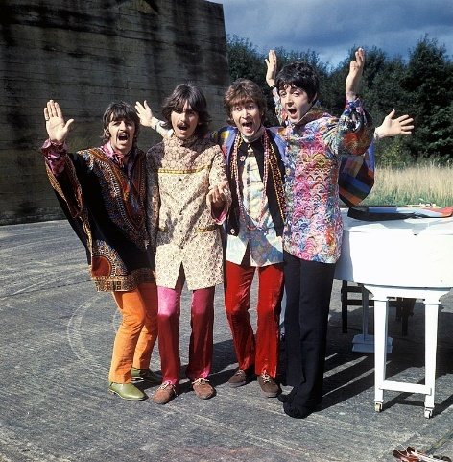
The Beatles are the best-selling music act of all time. As of 2017, they hold the record for most number-one hits on the Billboard Hot 100, with twenty. The group was inducted into the Rock and Roll Hall of Fame in 1988. The band received seven Grammy Awards, and an Academy Award.

