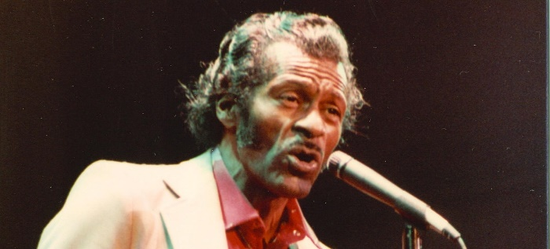
Chuck Berry
“Father of Rock n Roll”
1926-2017
Charles Edward Anderson "Chuck" Berry (October 18, 1926 – March 18, 2017) was an American singer, guitarist and songwriter. He is one of the original musicians who helped to create rock and roll.
Considered by many as the "father of rock 'n' roll," Chuck Berry had early exposure to music at school and church. As a teen, he was sent to prison for three years for armed robbery. He began producing hits in the 1950’s.
Early in 1955, Berry wrote and recorded a song called "Maybellene"; within months, "Maybellene" had reached No. 1 on the R&B charts and No. 5 on the pop charts. With its unique blend of a rhythm and blues beat, country guitar licks and the flavor of Chicago blues and narrative storytelling, many music historians consider "Maybellene" the first true rock 'n' roll song.
In 1985, he received the Grammy Lifetime Achievement Award. A year later, in 1986, he became the Rock and Roll Hall of Fame's first inductee. Perhaps the best measure of Berry's influence is the extent to which other popular artists have copied his work. The Beach Boys, the Rolling Stones and the Beatles have all covered various Chuck Berry songs.
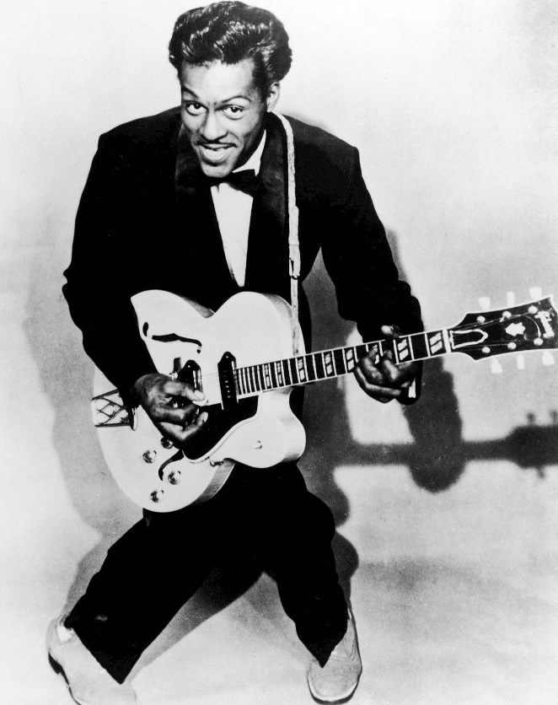
Berry died on March 18, 2017, at the age of 90. He is remembered as a founding father of rock 'n' roll, whose pioneering career influenced generations of musicians.

